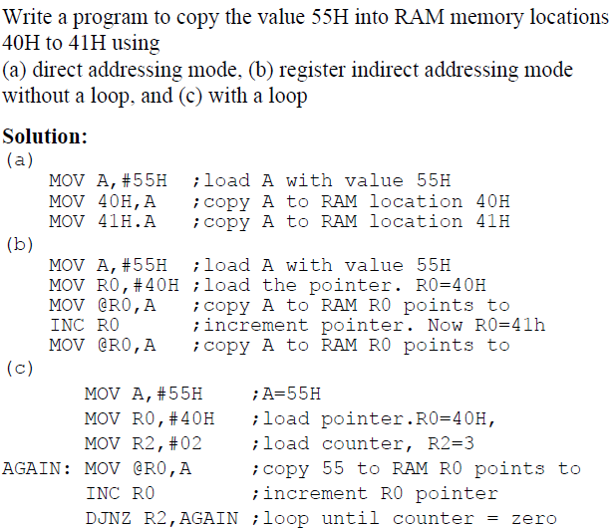

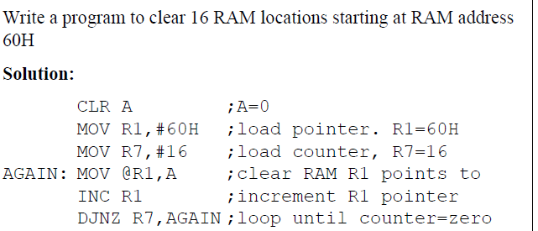

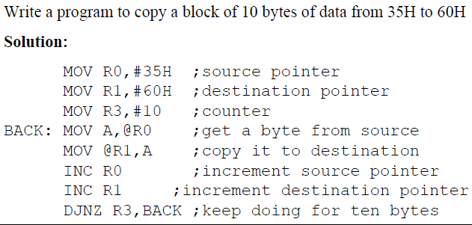
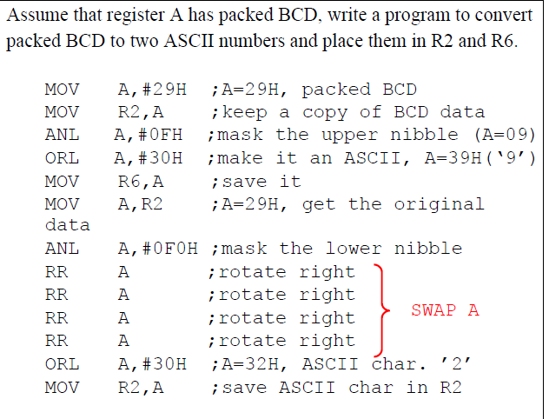

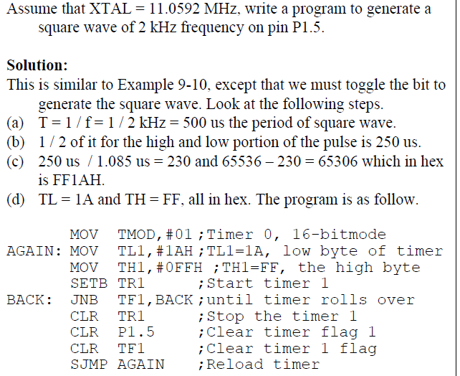
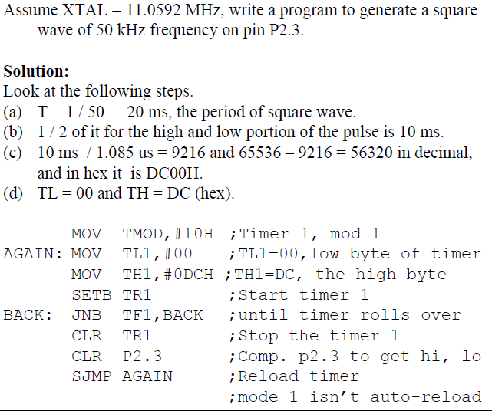

Logical operations for AND

MOV A,#35H ;A = 35H
ANL A,#0FH ;A = A AND 0FH

; Program: Perform addition using Immediate, Register, Direct and Indirect Addressing Modes
ORG 0000H
; ---------------------------------------------------
; Immediate Addressing Mode
; ---------------------------------------------------
MOV A, #25H ; Load first number directly into A
ADD A, #15H ; Add second number directly
MOV 30H, A ; Store result at RAM[30H]

; ---------------------------------------------------
; Register Addressing Mode
; ---------------------------------------------------
MOV R0, #12H ; Load first number into R0
MOV A, R0 ; Move R0 → A
MOV R1, #14H ; Load second number into R1
ADD A, R1 ; Add contents of R1
MOV 31H, A ; Store result at RAM[31H]

; ---------------------------------------------------
; Direct Addressing Mode
; ---------------------------------------------------
MOV 40H, #22H ; First number stored at RAM[40H]
MOV 41H, #11H ; Second number stored at RAM[41H]
MOV A, 40H ; Load first operand from RAM[40H]
ADD A, 41H ; Add second operand from RAM[41H]
MOV 32H, A ; Store result at RAM[32H]

; ---------------------------------------------------
; Indirect Addressing Mode
; ---------------------------------------------------
MOV R0, #50H ; R0 points to RAM[50H]
MOV @R0, #33H ; Store first number at RAM[50H]
INC R0 ; R0 = 51H
MOV @R0, #22H ; Store second number at RAM[51H]

MOV R0, #50H ; Point again to RAM[50H]
MOV A, @R0 ; Load first operand indirectly into A
INC R0 ; R0 = 51H
ADD A, @R0 ; Add second operand indirectly
MOV 33H, A ; Store result at RAM[33H]

; ---------------------------------------------------
; End of program
; ---------------------------------------------------
SJMP $ ; Infinite loop (stop execution)

END

